**P250/1**

**GEOGRAPHY**

**(Physical Geography)**

**Paper 1**

**July/Aug. 2017**

3 hours

**RESORCEFUL MOCK EXAMINATIONS 2017**

**UGANDA ADVANCED CERTIFICATE OF EDUCATION**

GEOGRAPHY

(PHYSICAL GEOGRAPHY)

**Paper 1**

3 Hours

**INSTRUCTIONS TO CANDIDATES**

*This paper consists of* **three** *sections***A, B** and **C**.

*Answer***four***questions.*

*Section***A** is **compulsory**.

*Answer* **one***question from section***B** and **one***question from section***C**.

*Credit will be given for use of relevant sketch maps, diagrams and specific examples studied in the field.*

*Any additional question (s) attempted will* **not***be marked.*

**SECTION A**

*Questions* ***1*** *and* ***2*** *are***compulsory**

**COMPULSORY MAP WORK QUESTION:**

1. Study the map extract 1:50,000 (Uganda) KIJURA part of sheet, 56/2 series Y732, Edition 3-1USD and answer the questions that follow:
2. (i) State the grid reference of the Secondary trigonometrical station at Mukihara. *(01mark)*

(ii) Name the relief feature found at grid reference 079942. *(01mark)*

(b) Calculate in kilometres the distance covered by the dry weather road from grid reference 150956 to grid reference 202978. *(02 marks)*

(c)(i) Draw a cross-section of the area between lines of easting 08 and 21, along line of northing 85, and on it mark and name;

* River,
* Hill summit,
* Settlement,
* Plantation,
* Roads. *(9 marks)*

(ii) Calculate the vertical exaggeration of the cross-section. *(2marks)*

(d) (i) Describe the economic activities taking place in the area. *(5 marks)*

(ii) Examine the relationship between relief and settlement in the area. *(5 marks)*

**COMPULSORY PHOTOGRAPH INTERPRETATION QUESTION**

1. 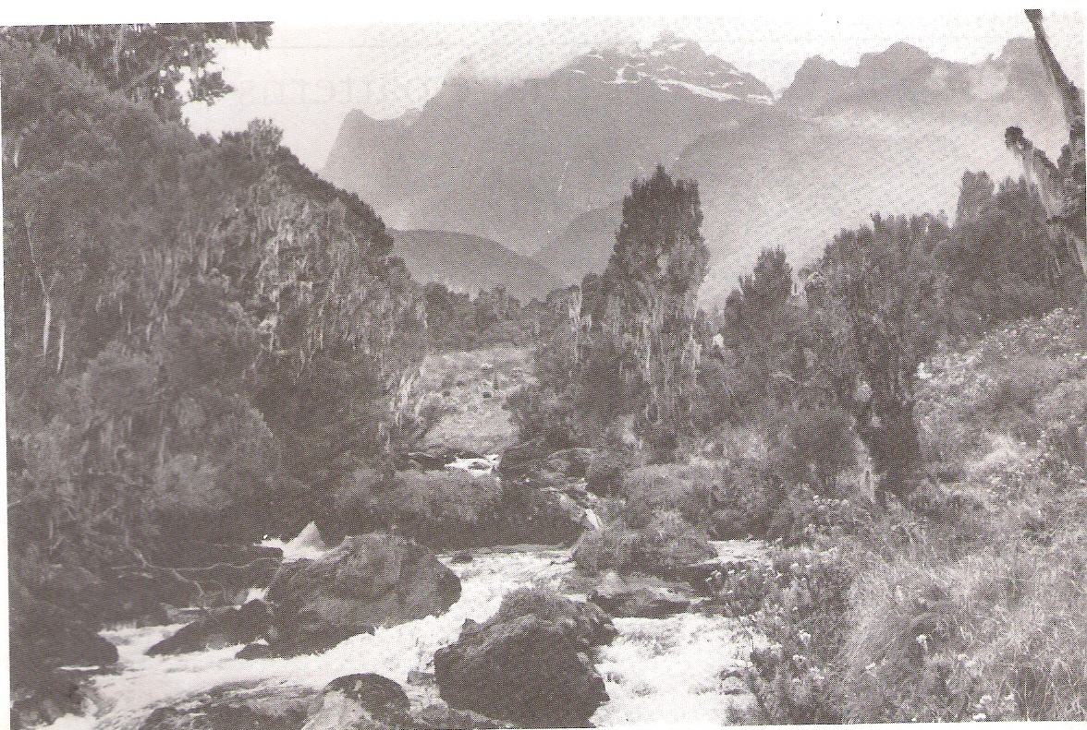Study the photograph provided below and answer the questions that follow:
2. Draw a landscape sketch of the area shown on the photograph and on it, mark and name;

* Glaciated peak,
* Trees,
* Boulders,
* Heath and moorland,
* River. *(8 marks)*

1. Account for the characteristics of the drainage feature in the photograph. *(4 marks)*
2. (i) Explain the major processes through which a river can erode its bed channel. *(5 marks)*

(ii) With evidence from the photograph, explain the problems faced by the people living in the area. *(6 marks)*

1. Giving reasons for your answer, suggest an area in East Africa where this photograph could have been take. *(2 marks)*

**SECTION B**

*Answer***one***question from this section.*

1. Examine the processes responsible for the formation of the various rock types in East Africa. *(25 marks)*
2. Account for the formation of glacial erosion features in the highlands of East Africa.

*(25 marks)*

1. To what extent does the subsidence theory account for coral reef formation in East Africa? *(25 marks)*

**SECTION C**

*Answer* **one***question from this section.*

1. Explain the causes and effects of tropical cyclones in their areas of occurrence. *(25 marks)*
2. With reference to any one highland area in East Africa, describe the relationship between altitude and the prevailing vegetation zones. *(25 marks)*
3. “Man’s activities more than anything else are responsible for the extensive soil erosion in East Africa.” Discuss. *(25 marks)*

**END**